**Hierarchical Clustering**

**Instructions:**

Please share your answers wherever applicable in-line with the word document. Submit code separately wherever applicable.

Please ensure you update all the details:

**Name: _Naveen Kumar Uppara____________ Batch ID:** ____07092022_______

**Topic: Hierarchical Clustering**

**Guidelines:**

**1. An assignment submission is considered complete only when correct and executable code(s) are submitted along with the documentation explaining the method and results. Failing to submit either of those will be considered an invalid submission and will not be considered as correct submission.**

**2. Ensure that you submit your assignments correctly and in full. Resubmission is not allowed.**

**3. Post the submission you can evaluate your work by referring to keys provided. (will be available only post the submission).**

**Hints:**

**1. Business Problem**

* 1. **What is the business objective?**
  2. **What are the constraints?**

**2. Work on each feature of the dataset to create a data dictionary as displayed in the below image:**

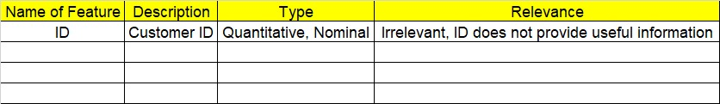

**3. Data Pre-processing**

**3.1 Data Cleaning, Feature Engineering, etc.**

**4. Exploratory Data Analysis (EDA):**

**4.1. Summary.**

**4.2. Univariate analysis.**

**4.3. Bivariate analysis.**

**5. Model Building**

**5.1 Build the model on the scaled data (try multiple options).**

**5.2 Perform the hierarchical clustering and visualize the clusters using dendrogram.**

**5.3 Validate the clusters (try with different number of clusters), label the clusters, and derive insights (compare the results from multiple approaches).**

**6. Write about the benefits/impact of the solution - in what way does the business (client) benefit from the solution provided?**

**Problem Statements:**

1. Perform clustering for the airlines data to obtain optimum number of clusters. Draw the inferences from the clusters obtained. Refer to EastWestAirlines.xlsx dataset. Business Objective: Optimization of rewarded miles

Constraints: balance miles

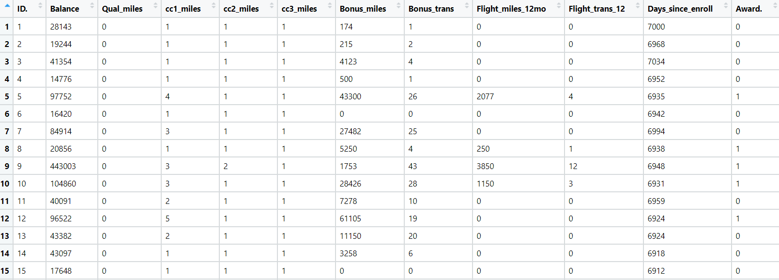

1. Perform clustering for the crime data and identify the number of clusters formed and draw inferences. Refer to crime_data.csv dataset.

Business objective: To optimize the crime rate

Constraints: Urban population

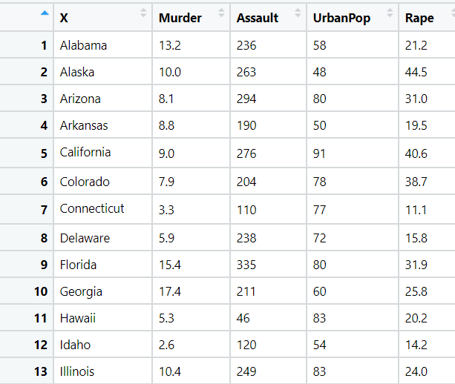

1. Perform clustering analysis on the telecom data set. The data is a mixture of both categorical and numerical data. It consists of the number of customers who churn out. Derive insights and get possible information on factors that may affect the churn decision. Refer to Telco_customer_churn.xlsx dataset.

Business objective: Reduce churns

Constraints: Type of connection, revenue

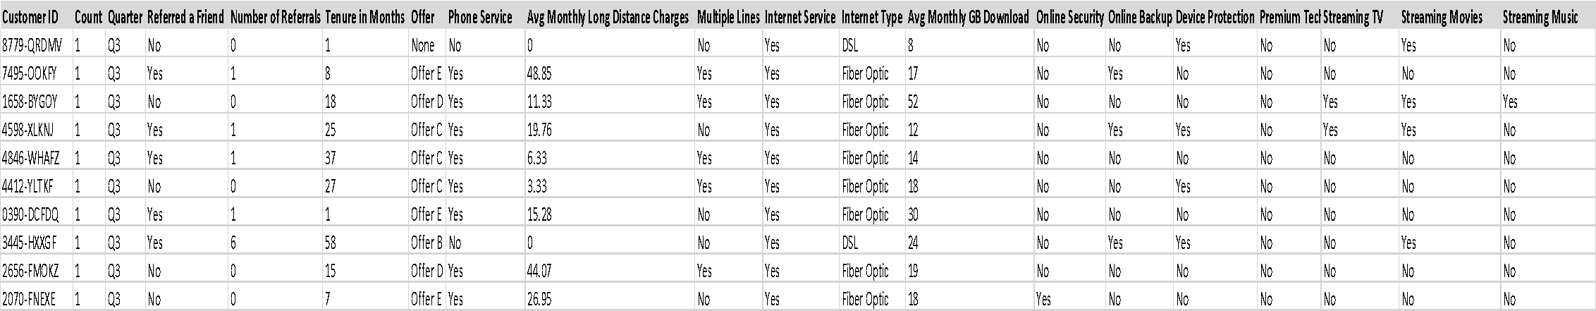

1. Perform clustering on mixed data. Convert the categorical variables to numeric by using dummies or label encoding and perform normalization techniques. The data set consists of details of customers related to their auto insurance. Refer to Autoinsurance.csv dataset.

Business objective: maximize insurance policies

Constraints: Location, Education and Response rate

